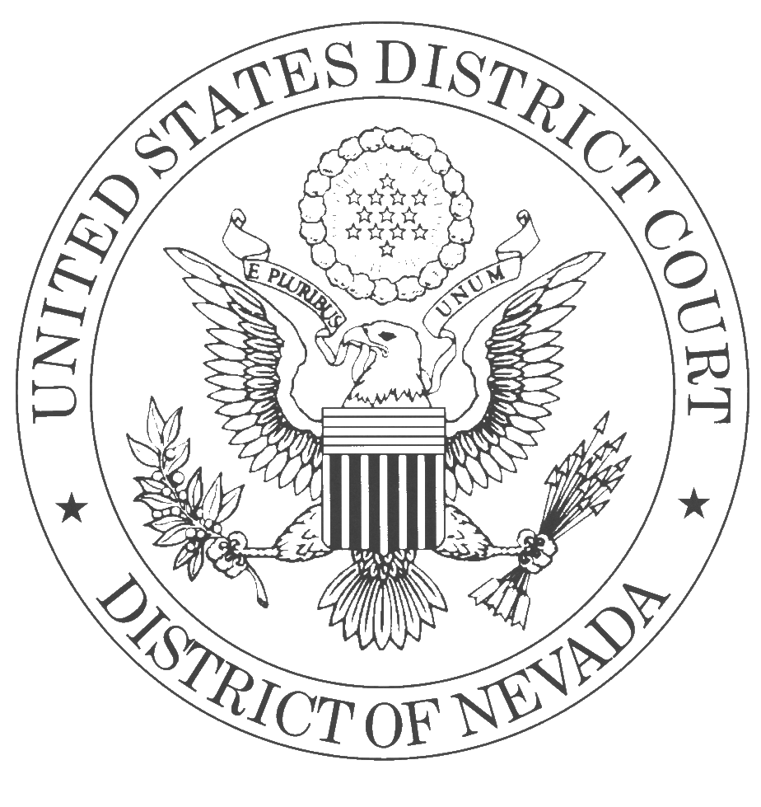
United States District Court
District of Nevada
Chambers of  Miranda M. Du  Chief Judge |  | Bruce R. Thompson U.S. Courthouse & Federal Building  400 South Virginia Street  Reno, Nevada 89501  (775) 686-5919

March 16, 2020

PRESS RELEASE

The U.S. District Court for the District of Nevada and the U.S. Bankruptcy Court for the District of Nevada have been monitoring the national and state and local responses to the coronavirus disease (COVID-19) outbreak and its potential impact on our communities. The Governor of the State of Nevada has declared a public health emergency throughout the state in response to the spread of COVID-19 in Nevada. Moreover, the President of the United States has declared a national emergency. The Court is therefore taking the following temporary actions both in response to these emergency declarations, and to do its part in slowing the spread of COVID-19—to lessen COVID-19’s impact on the public and the public health system: (1) all trials are continued until April 10, 2020; (2) all non-case related events are postponed; (3) naturalization ceremonies through March are postponed although the Court will explore options to allow for prompt make-up ceremonies to occur; and (4) building entrance protocols have been adopted for all four federal courthouses to restrict access by persons who present COVID-19 risks, including those who have been diagnosed with COVID-19 and those with apparent symptoms of COVID-19.

Detailed information about the two applicable general orders can be viewed at www.nvd.uscourts.gov.

